
Year 11 Essentials

Mini Test 1.3

Rates, Perimeter and Area

Resources allowed: Calculator and 1 x A4 page one side
Name:________________

Show all working out for full marks | Total: /20

- What unit of measurement would you use to measure the following things [3]
- Flow rate of a hose?

- Speed of a bird flying?

- Swimming speed of a human?

- If you have a 2.5m piece of wood, and you needed 6 pieces cut, estimate how long should each piece be?(nearest 10cm) [2]

- If a room is 6.2 metres long, and 4.8 meters wide, estimate how big is the room is to the nearest square meter? (hint- draw a diagram and don’t give exact answer) [3]

- Find the perimeter of the following shapes [2]

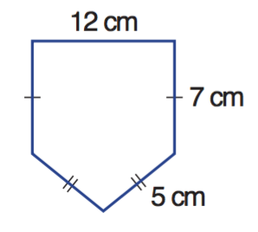
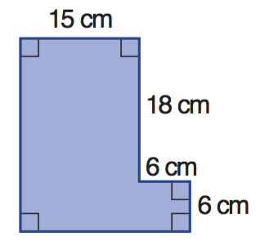
a b

P =____________________ P =____________________

- Use the following table to convert these imperial units to SAE [8]
IMPERIAL | METRIC
1 inch | 2.54cm
1 foot | 30.4cm
1 yard | 91.44cm
1 mile | 1.609km
- 30 feet to meters

- 40 inches to centimetres

- 65 metres to yards

- 60 miles to Kilometres

- If 1 square foot is equal to 0.093m2, how big is a 2500 square foot house in m² ? [2]

